Web Technologies - Lab

Submitted By:
Sr# | Name | Section | Roll Number | Semester
1 | Hafiz Muhammad Hamza Khalid | G | Fa2023-BSCS/283 | 5th

Submitted To:
___________________ (Signature)
Sir Yousuf.


Department Of Computer Science
Lahore Garrison University
Lahore

- Installing Web-Browser.
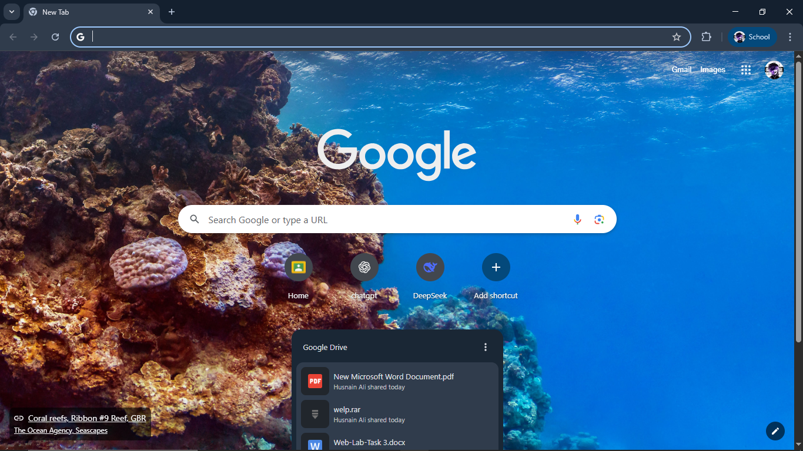
- Installing VS-Code
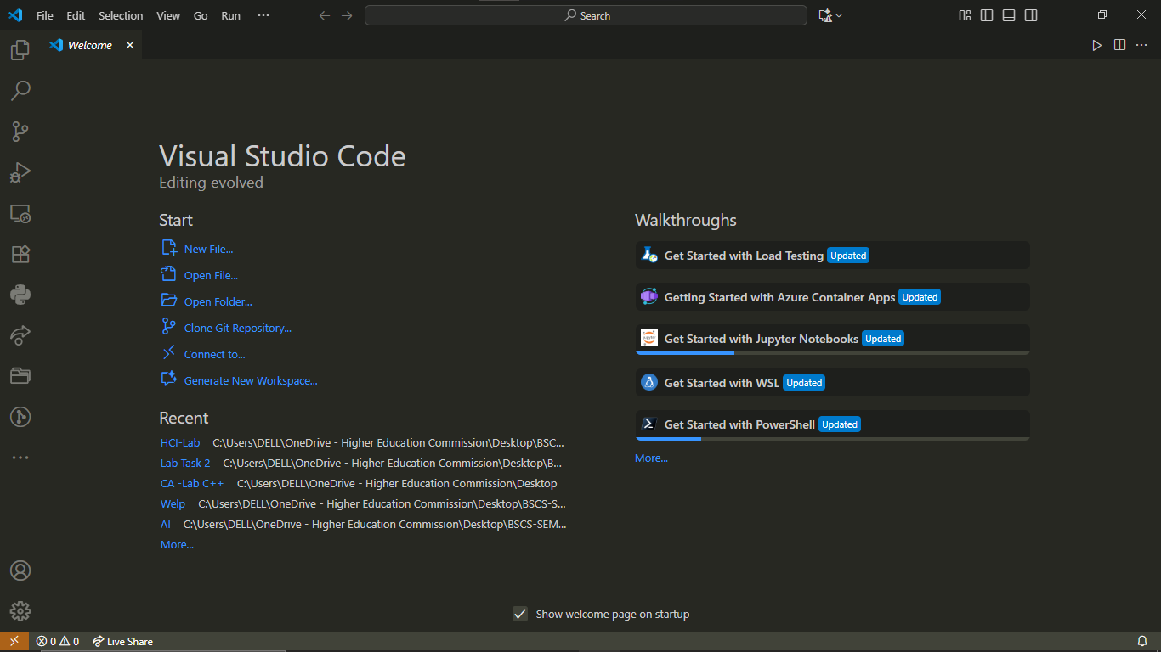
- Making Folders And Git-init
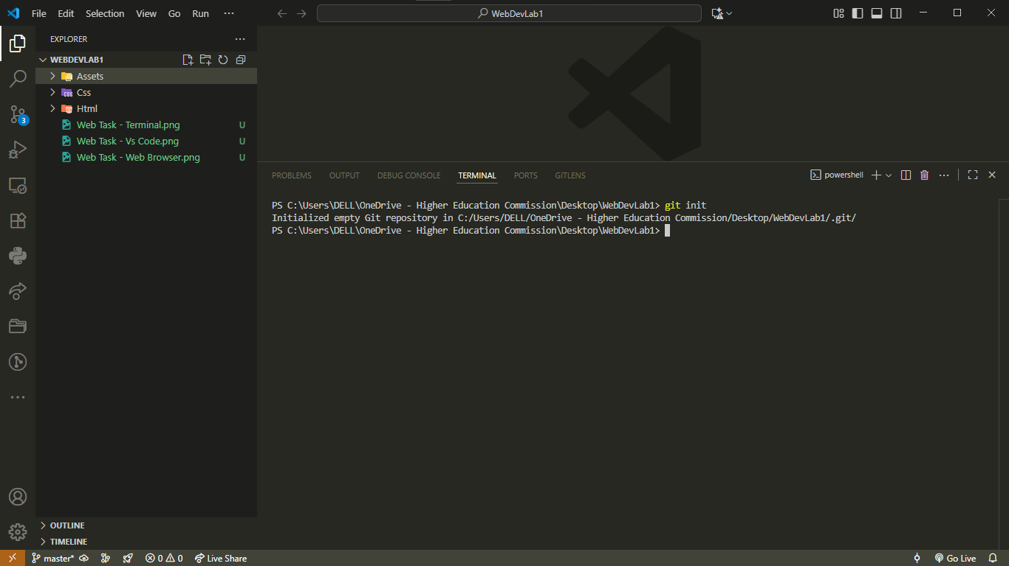
- User & Email Verification ( Git )
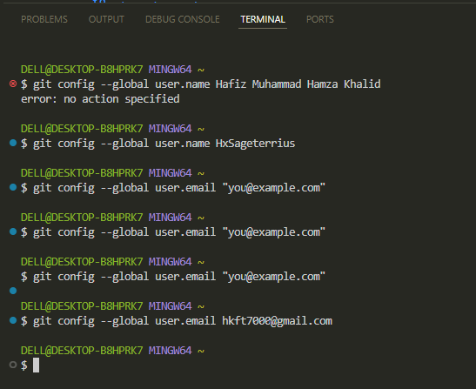
- Installing Live server
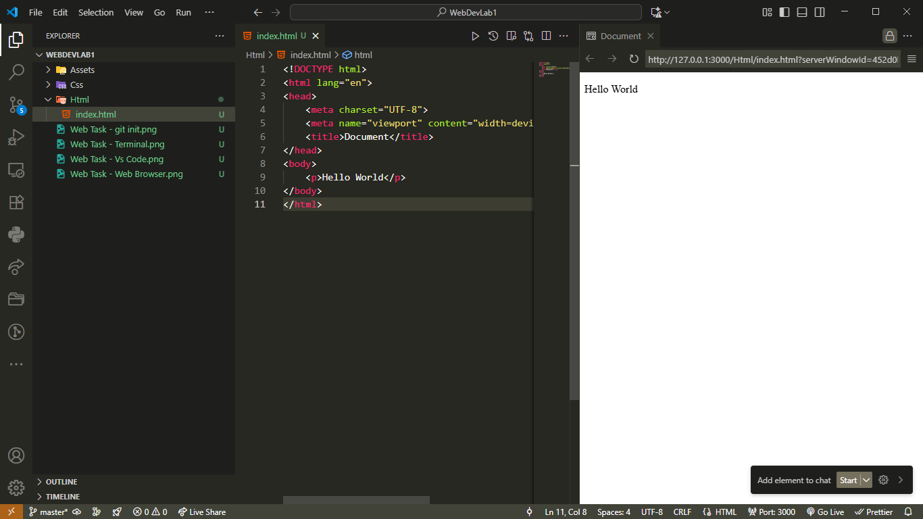
- Verifying.......
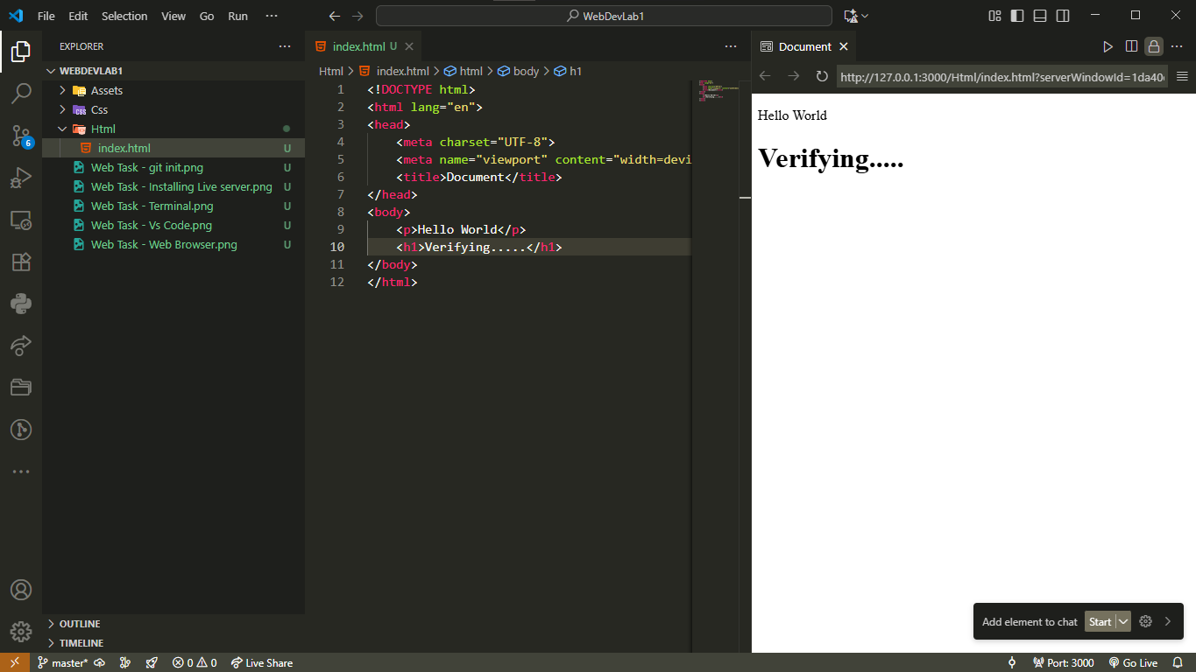

@@@@ --------The End --------@@@@

